Issues Found in Vuseharvest

1. **Sections Overlapping with each other**

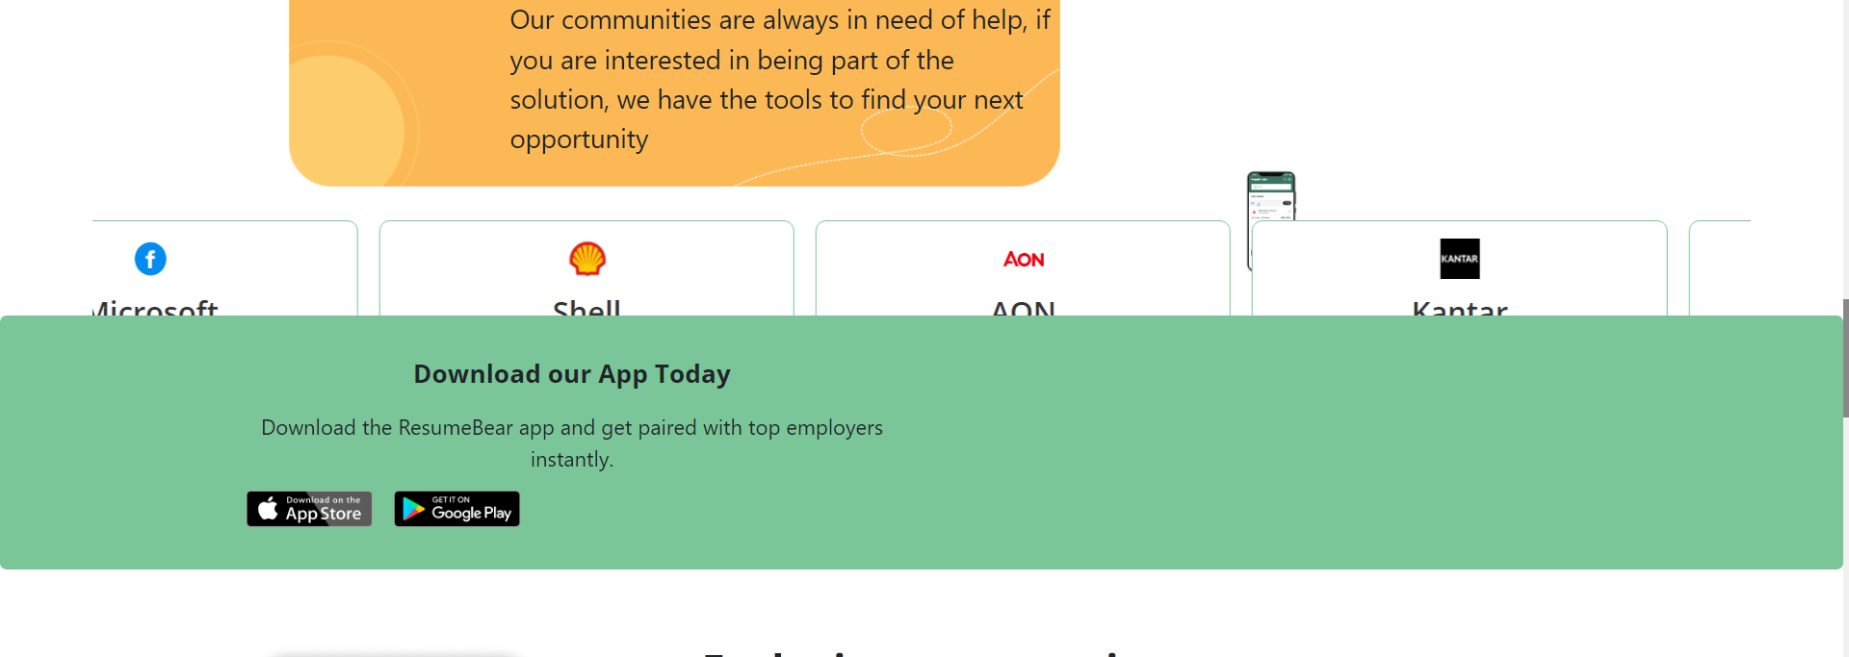

1. **Register button not clickable**

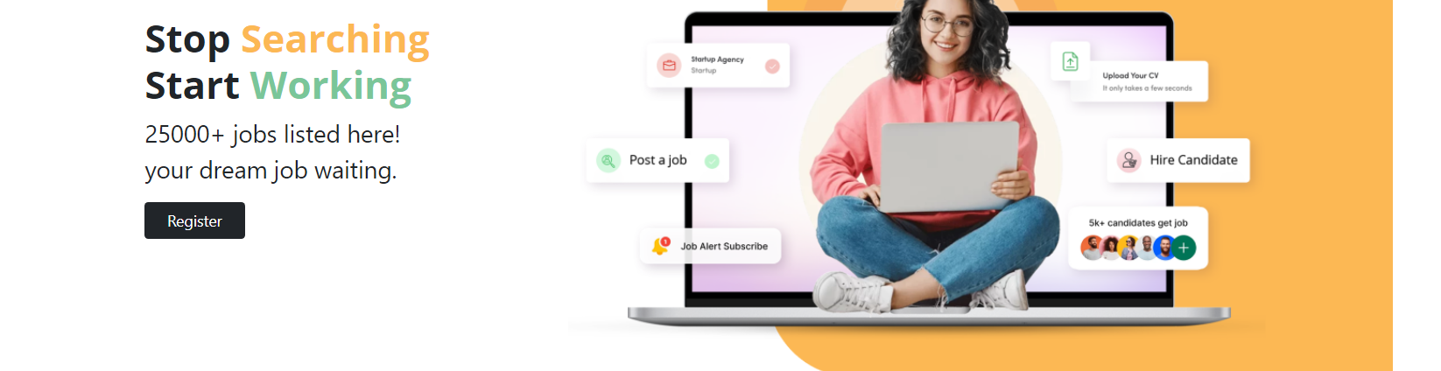

1. Logged in user should not see login page without Logging Out by typing URL or by clicking browser back button.



1. Section height and width should not change while hovering same in UI/UX section.

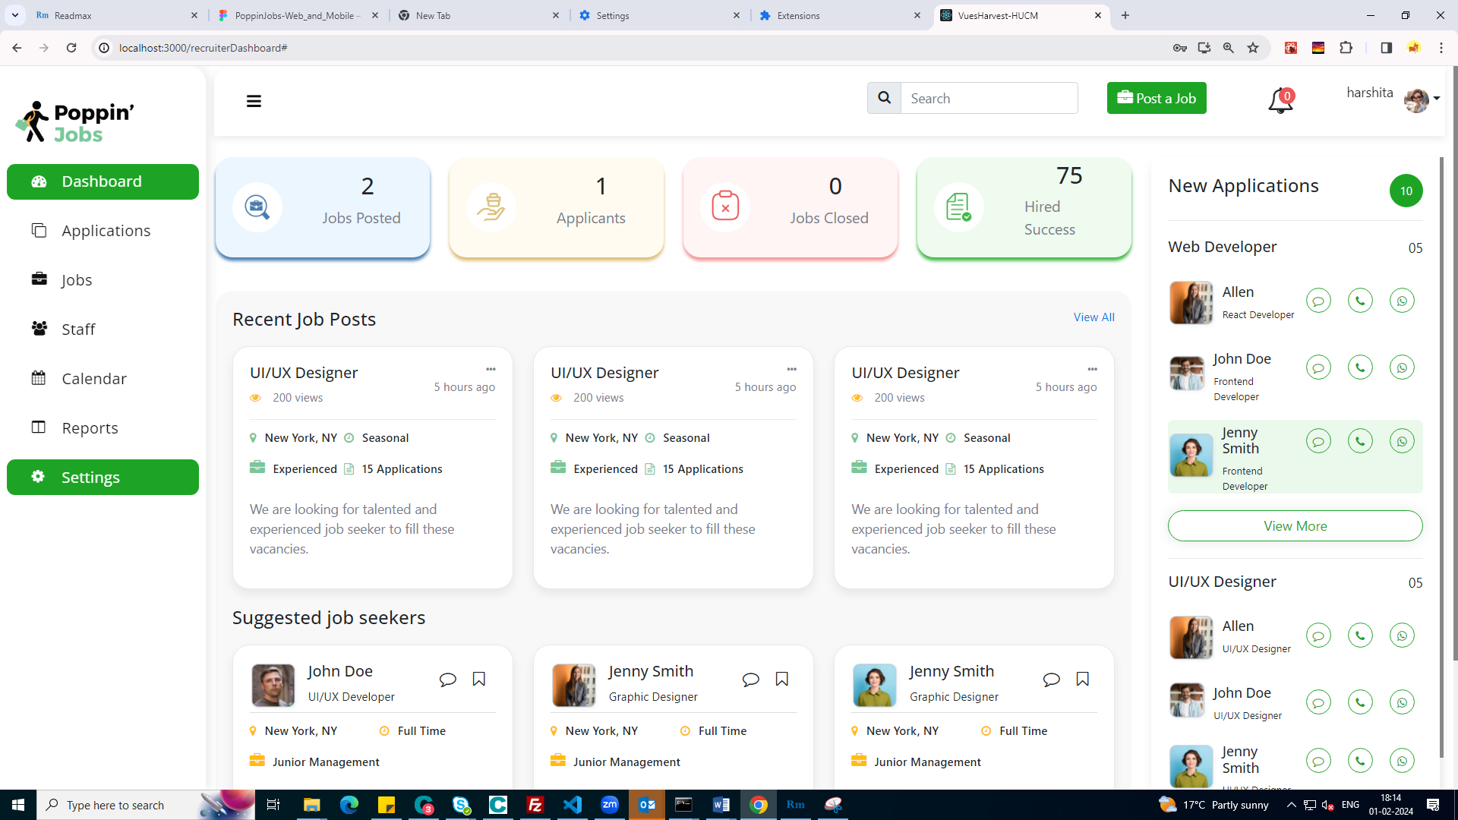 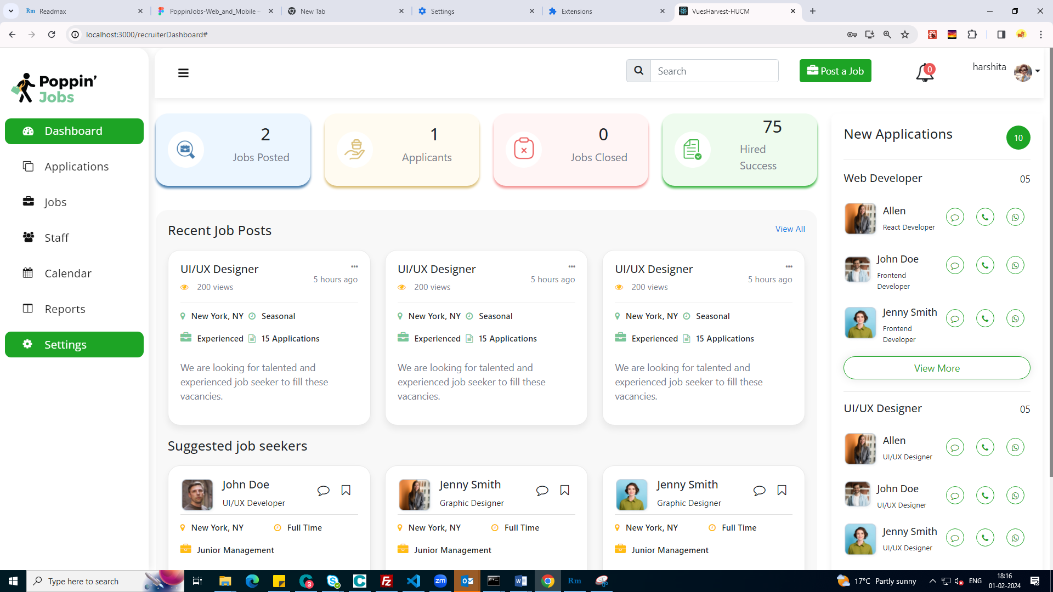

1. On clicking on particular form we are unable to open that form directly on Edit Mode.

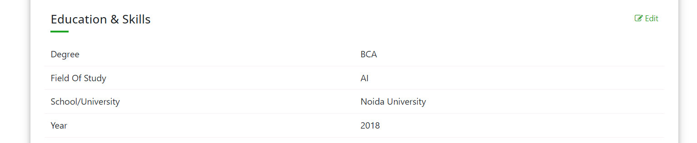

1. We are unable to search after using Enter button Press, Searched Items should be written same as highlighted text in text input.

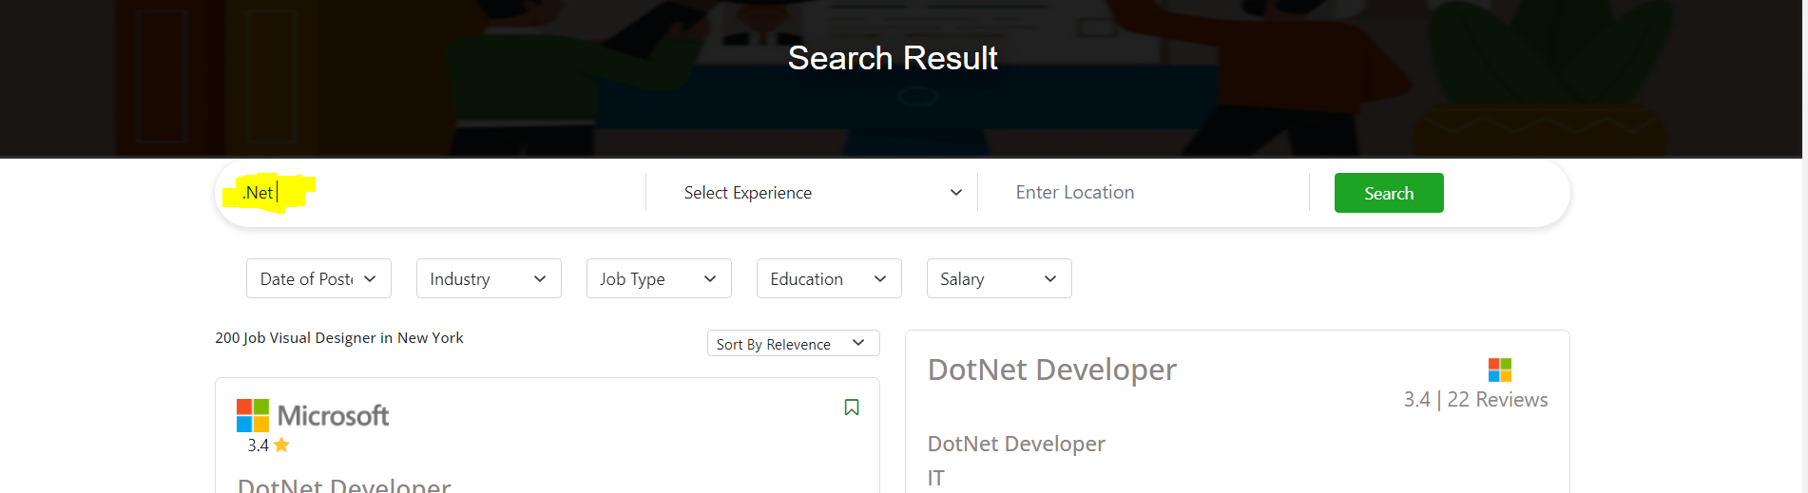

1. We should show tooltip save/un-save job on this icon nothing happens on again clicking on this icon after job was saved user will not get to know what is going on.

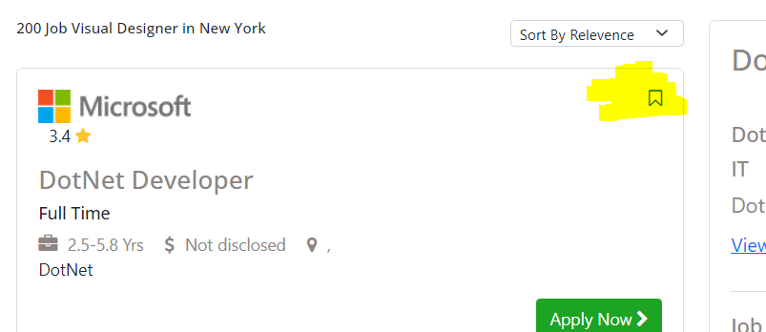

1. **Applied job from search page, not showing on applied job Listing Page.**

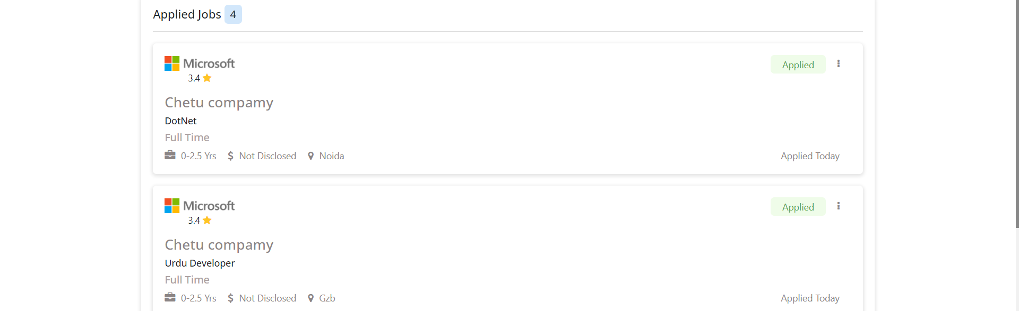

1. **Search Job functionality is not implemented correct way, we are getting bad request while sending request also user in unable to see error.**

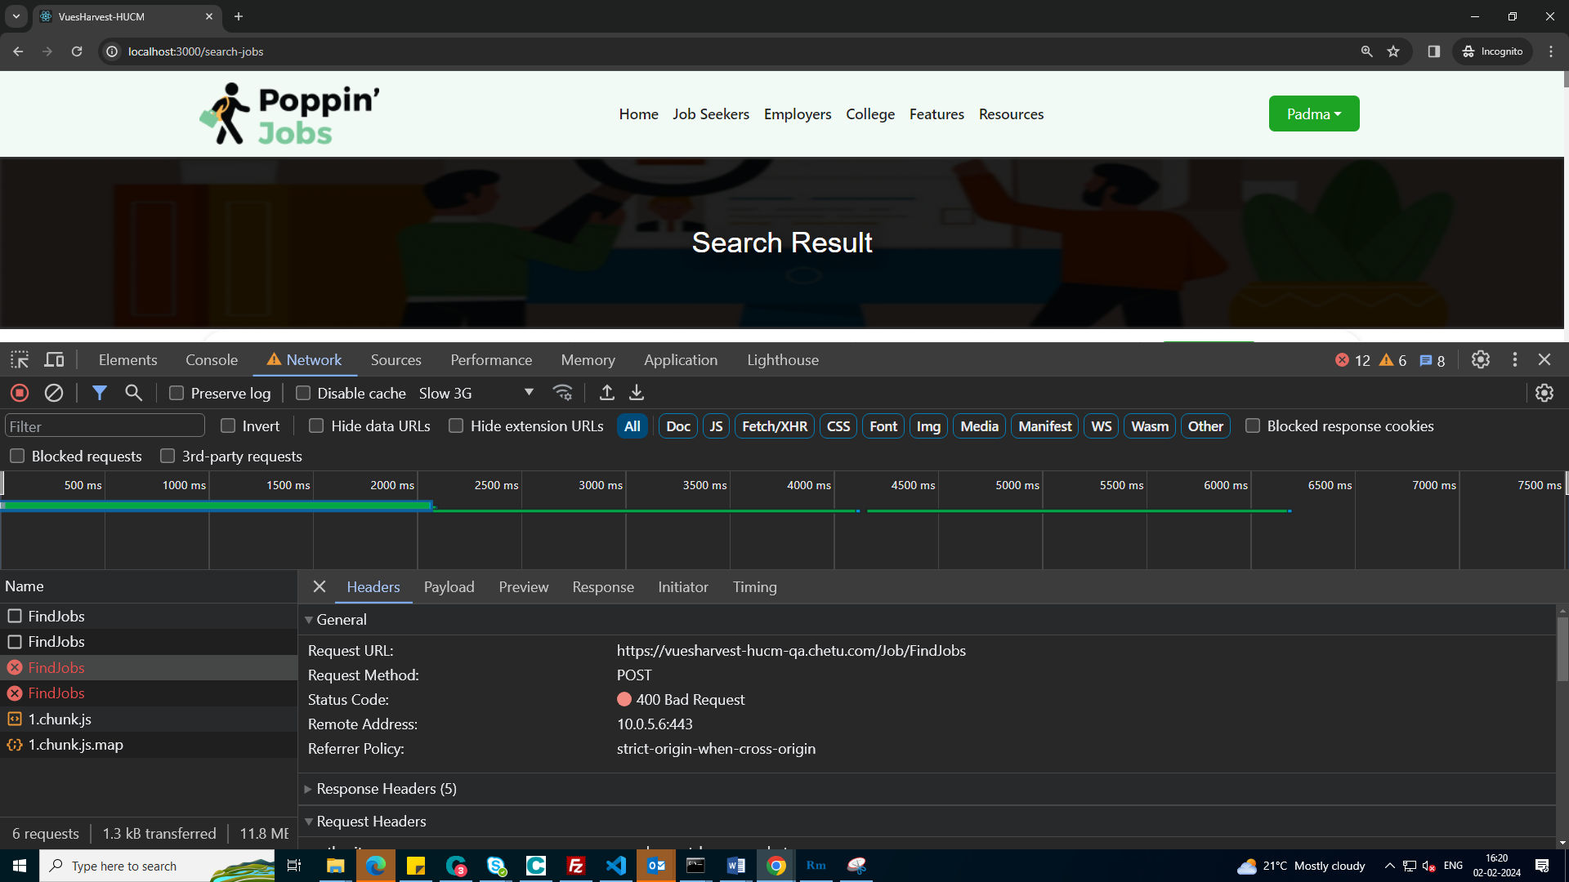

1. **Save job and apply job button is not functional**

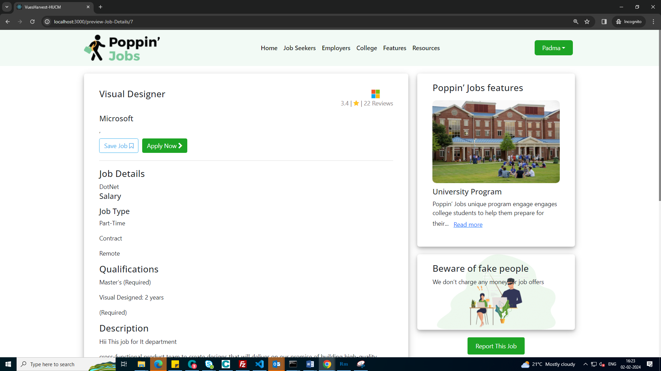

1. **Short by relevance, functionality not implemented**

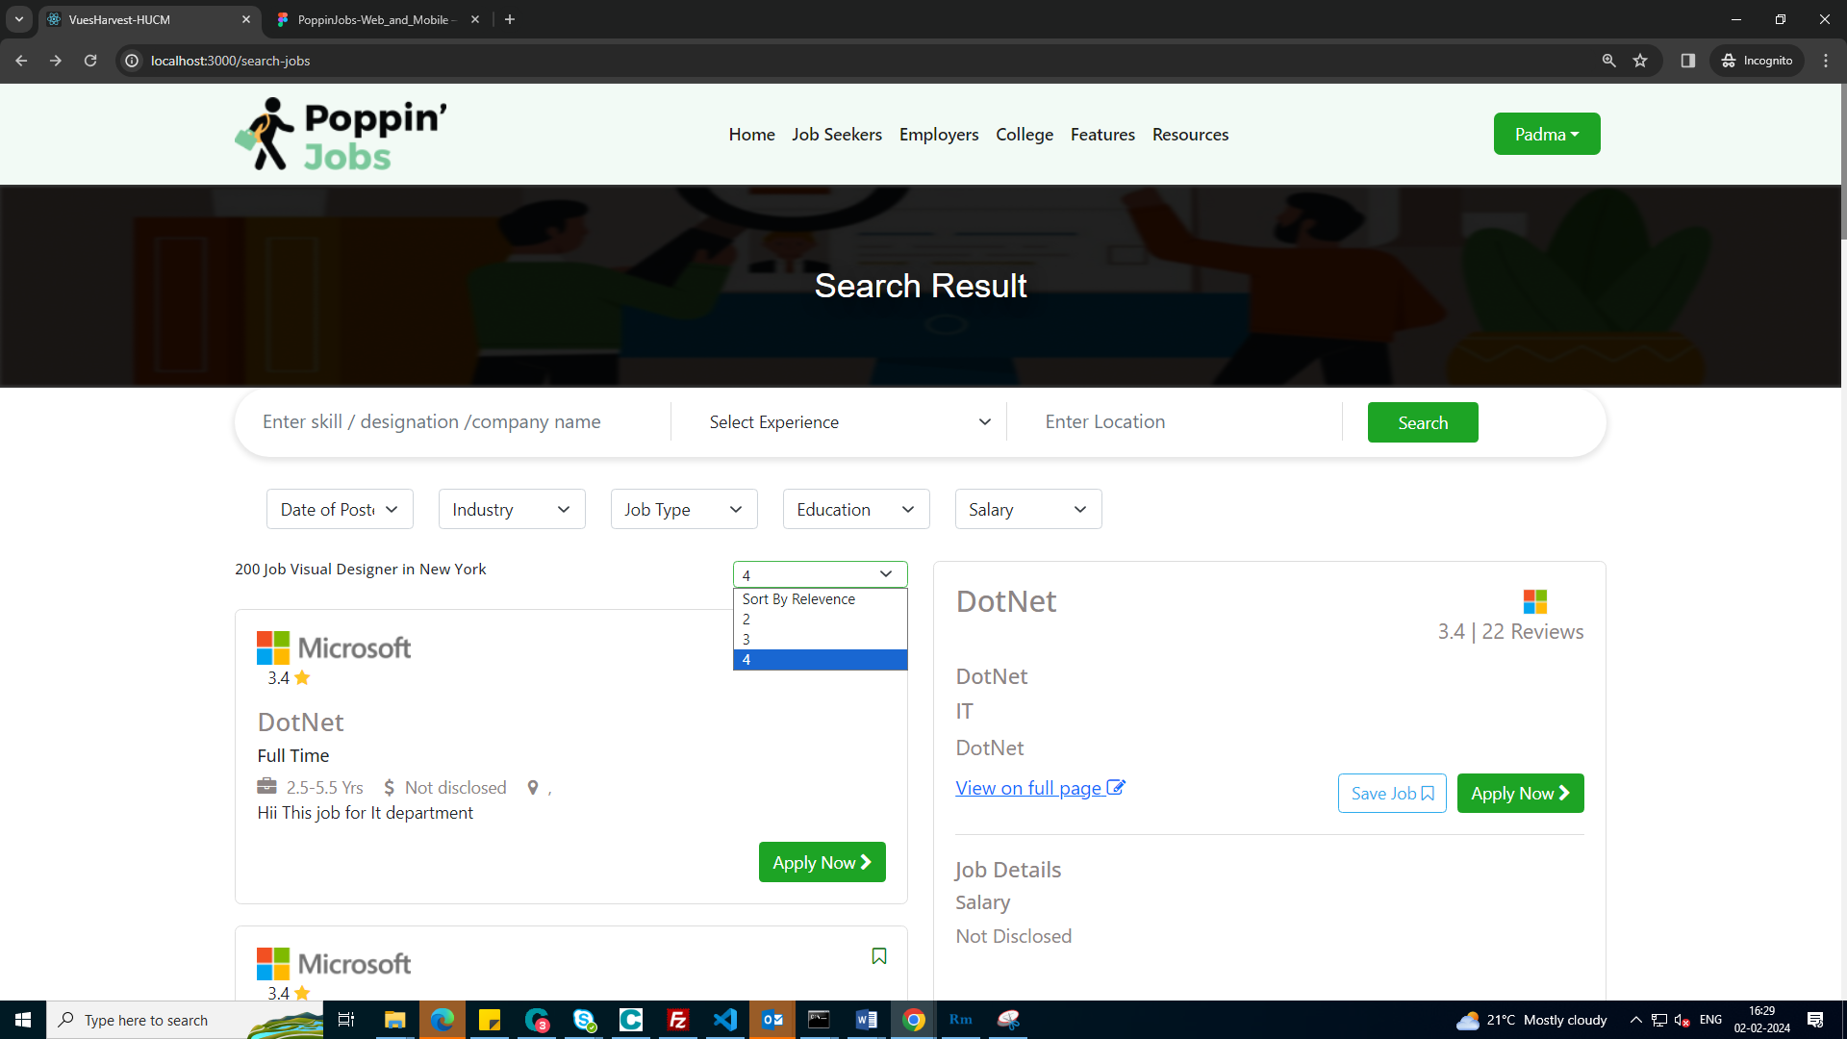

1. **Apply job giving unauthorized. I had suggested to create method in webapi to logout user if getting 401 error.**

